# Flow Documentation - Fetchallpowerautomateruns-DEC7F7F0-49DB-EF11-8EEA-6045BD08D9EE

|  |  |
| --- | --- |
| **Flow Name** | Fetchallpowerautomateruns-DEC7F7F0-49DB-EF11-8EEA-6045BD08D9EE |
| **Documentation generated at** | 01 February 2025 05:27 PM |
| **Number of Variables** | 0 |
| **Number of Actions** | 2 |

## Flow Overview

The following chart shows the top level layout of the Flow. For a detailed view, please visit the section called Detailed Flow Diagram

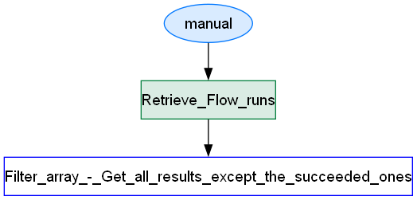

## Connections

There are a total of 1 connections used in this Flow:

### shared

|  |  |
| --- | --- |
| **Connector** | [shared](https://docs.microsoft.com/connectors/shared) |
| **Connection Type** | ConnectorReference |
| **Connection Reference Name** | ppac_sharedppac5fpower20automate20flow20runs5f47e8987c13b6fdb1_3355e |
| **Source** | invoker |

## Variables

## Trigger

|  |  |
| --- | --- |
| **Name** | manual |
| **Type** | Request |
| **Inputs Details** | |
| **schema** | |  |  | | --- | --- | | type | object | | properties |  | | required |  | |
| **Other Trigger Properties** | |
| **metadata** | |  |  | | --- | --- | | operationMetadataId | 46785f08-a820-40fb-828c-a82d47a944ae | |
| **kind** | Button |

## Actions

There are a total of 2 actions used in this Flow:

### Retrieve_Flow_runs

|  |  |
| --- | --- |
| **Name** | Retrieve_Flow_runs |
| **Type** | OpenApiConnection |
| **Inputs** | |
| **metadata** | |  |  | | --- | --- | | operationMetadataId | a610a64b-977f-4f53-bff8-988e75efc04f | |
| **host** | |  |  | | --- | --- | | connectionName | shared_ppac-5fpower-20automate-20flow-20runs-5f47e8987c13b6fdb1 | | operationId | Retrieve_Flow_runs | | apiId |  | |
| **parameters** | |  |  | | --- | --- | | FlowEnvironment | aff571f1-f11d-e16a-b440-3cdb90e86c0d | | FlowGUID | 80a1433e-07ea-4dc4-b1ca-f20933ddc604 | |
| **authentication** | |  |  | | --- | --- | | type | Raw | | value | @json(decodeBase64(triggerOutputs().headers['X-MS-APIM-Tokens']))['$ConnectionKey'] | |
| **Next Action(s) Conditions** | Filter_array_-_Get_all_results_except_the_succeeded_ones [Succeeded] |

### Filter_array_-_Get_all_results_except_the_succeeded_ones

|  |  |
| --- | --- |
| **Name** | Filter_array_-_Get_all_results_except_the_succeeded_ones |
| **Type** | Query |
| **Inputs** | |
| **metadata** | |  |  | | --- | --- | | operationMetadataId | 3b1e185e-6712-4414-9110-1e58c295245d | |
| **from** | @body('Retrieve_Flow_runs')['value'] |
| **where** | @not(equals(item()?['properties']?['status'], 'Succeeded')) |

## Detailed Flow Diagram

The following chart shows the detailed layout of the Flow

